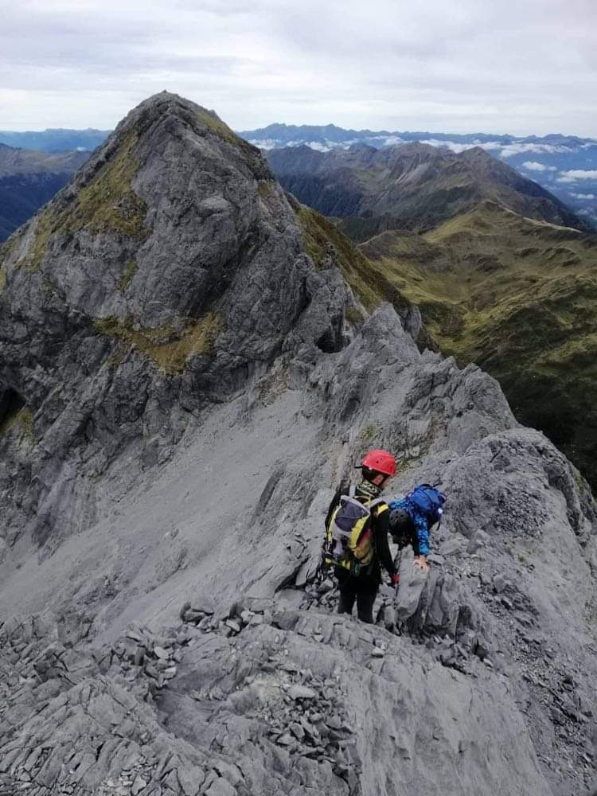
NZ ALPINE CLUB
NELSON/MARLBOROUGH
NEWSLETTER
APRIL 2021

Russell Adams – Chairman, Social Media r.a.guns.70@gmail.com | Liam Sullivan – Treasurer, Club Gear  liam _sullivan@yahoo.com
Glen Aspin – Social Media  aspojay@gmail.com | Morgan Puklowski – Secretary/BANFF Committee  morgan.puklowski@gmail.com
Bruce Davies – Club Meetings daviesrobin@yahoo.com | Jerome Waldron – Marlborough Committee Rep jjwaldron@xtra.co.nz
Josh Knox – BANFF Coordinator/Newsletter  joshknox@yahoo.com | Brandon Kay – BSCC Coordinator  braknn007@gmail.com

Club News
Can now be found on the website. There are news items and trip reports from all over the country.
Click HERE to go there now!
Follow Us On Facebook
No need to be a Facebook User
Click HERE
Section Gear Hire
The Nelson section gear (ice axes, avo gear, locater beacon etc) is available to all section members.
Contact Liam Sullivan liam_sullivan@yahoo.com
Club Donations
We have a link online where members can DONATE
Members can also use our bank account 03 0502 0607822 00, or send in a cheque (NZ only).
Click HERE

Chairman’s Report

Hi all and welcome to the first newsletter of 2021 for the Nelson Marlborough section. While we are turning our thoughts to the approaching winter season which is exciting, it's also crazy to think we're in mid-April already! On that note, I hope everyone had a great summer and managed to get out and about on some awesome adventures, but now it's time to dust off the crampons and ice axes and get ready for some of the cold white stuff :)
The committee got together in late March to commence planning and thoughts for the season ahead and there was quite a bit to get through as well as some changes to the committee team. Reuben McCormack, who has been an integral part of the team with his contributions to Banff and the section in general, is relocating to the West Coast for a while and so has resigned from the committee although will still have some involvement going forward in various section activities. On behalf of the committee and no doubt the section members, I just want to pass a huge thank you to Reuben for all his effort and contribution.
After some consideration, I have also decided to step down from my role as Chairman of the section due to a few too many other commitments on my plate currently and so it seemed appropriate to do this before we get into the new season ahead and let some else drive things for a while. I'll still have limited involvement in the committee, mainly in relation to the Basic Snow Craft Course and possibly some club trips, but otherwise you are in great hands with a fantastic and dedicated committee. The committee upon receiving and accepting my resignation, managed to convince/vote in, Russell Adams to step in and fill the role of Chairman through to the next AGM. Russell is a young and passionate club member and no doubt will bring enthusiasm and value to the role. Russell is well supported and I'm confident will help keep progressing the section in a positive direction, so thank you Russell and best of luck.
There's some great items worth noting on the calendar this year beginning this month, so keep reading on and be sure to pencil them in.
Thanks everyone, enjoy the season ahead and no doubt I'll see you about either at some of the section events or in the mountains.
Cheers
Brandon

Upcoming trips/Courses

Avalanche course - July.

Matt Wilkinson will run his hugely popular avalanche course again this winter, dates to be confirmed, but we are looking at sometime in July. This will be a classroom type evening followed by a field day. Hopefully we get some snow this year so we can do some snow analysis!!
There will be more details closer to the time.

Club Trips 2021

So far we have a few trips up our sleeve, but we are always keen to hear of a new idea and also any trips that our members would like to do. So if you have an idea for a trip then please contact Glen on aspojay@gmail.com with your idea and we will see if we can make it happen.
In the next newsletter there will be a full list of trips for this winter.

Basic Snow Craft Course (BSCC)

We will run the BSCC this year on the weekend of 20-22 August. It will be based out of St Arnaud with the days being at Rainbow Ski Field. This is a hugely popular course designed for complete beginners to gain confidence and skills to walk on snowy (frozen) terrain, then use those skills on a day out. The BSCC fills up very fast so if you are interested then contact Brandon (braknn007@gmail.com) for more details.

Club Nights/Events

Club Night - 14 April, 7pm at The Honest Lawyer.

Top of The South Guidebook Launch.
The updated guidebook for the Nelson/Marlborough area was published at the end of last year. The original author Ben Winnubst worked extensively on this edition also and will give a presentation on some of the routes in the new book. Ben has climbed everything in the Nelson/Marlborough area and has had a huge input to the club and this book. No doubt this will be a very informative evening, so bring your new guidebook along and get him to sign it for you! (The latest addition will be available for purchase on the night, and can also be purchased from the NZAC website).

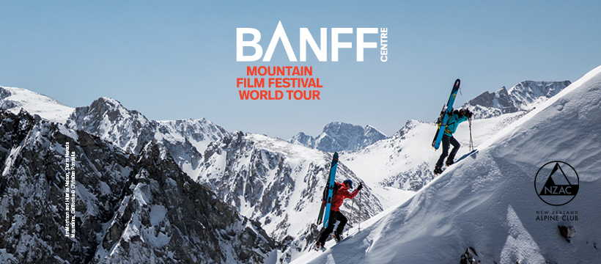
BANFF Film Festival

The Banff Film Festival is on again this year and scheduled for 11th and 12th of June and once again there are some epic movies to inspire and excite, especially needed as travel has been a bit restricted of late.
There will again be different programs running each night and films covering a huge variety of sports and showcasing some amazing locations.
Hope to see you there. Tickets are now on sale, follow the link below.
https://www.eventbrite.co.nz/e/banff-mountain-film-festival-world-tour-nelson-2021-tickets-148882695149
https://www.facebook.com/events/198106782076717
Notices

Donation of Alpine gear.

A big THANK YOU to Jim Young for the donation of some of his alpine gear. It will get put to good use by members as part of our loan gear.
If you have any Alpine gear that is of good condition that you are not using, consider donating it to the section. It will get used to help starting out members to get into the hills through our gear loan scheme. Contact Liam (liam_sullivan@yahoo.com) if you have anything to donate.

Cover photo: South Twin taken from the North Twin (The Twins - Arthur Range) by George Guille.

